Curvature of the horizon
Abstract: Followers of the flat Earth idea frequently use quantities like distance to the horizon and its dip. Mathematical expressions for these can be easily derived and formulae for good practical approximations are well known in literature. For example the dip in arc minutes is calculated as 1.78·√h, where h, the height of the observer, is expressed in meters. Such formulae are also derived in this article but what is new here is the formula for curvature of the horizon as seen from the perspective of an observer. If the observer sees a part of the horizon contained within the angle γ then the horizon arc in the middle of this field of view will be seen higher than the ends of the arc (i.e. above the chord) by the angle (again in arc minutes):
g = 1.78·√h·[1/cos(γ/2) – 1].
This is just the dip scaled by the factor 1/cos(γ/2) – 1. This formula proves quite accurate and thus it can be safely used by all flat earthers. Assessment of its accuracy can be made by comparing the results it gives with the results obtained from exact solution as given in the Table 2 below. For example, this formula errs by less than 1% for h ≤ 100 000 m and γ = 90°, or h ≤ 50 000 m and γ = 120°, or h ≤ 10 000 m and γ = 150°. Actual observations presented in this web site are shown to agree with our theoretical calculations.
Flat earth believers often cite the lack of evidence for the earth's sphericity, in particular the fact that the curvature of the horizon is not visible on a daily basis, even at considerable heights. I recently watched a video by someone from Poland who planned to send a balloon with equipment high enough to show that the curvature is not visible there either. Stratospheric balloons usually rise to an altitude of 20-40 km (the record being 43,561 m).
The difficulty in seeing the curvature with the naked eye or in photographs is simply due to the smallness of the curvature. Nevertheless, the fact that the horizon is lowered has been repeatedly verified experimentally. A good example of ground measurements with a theodolite is presented in the video here.
The formulas for calculating the distance to the horizon and its lowering or dip relative to the plane perpendicular to the vertical at the observer's location are quite simple – they can be easily found in the literature. However, calculating the expected amount of curvature of the horizon in photographs of a section of the horizon is somewhat challenging, which prompted me to develop the precise solutions presented here. They will allow for more reliable planning of possible attempts to experimentally confirm or disprove the sphericity of the Earth.
The distance and dip of the horizon
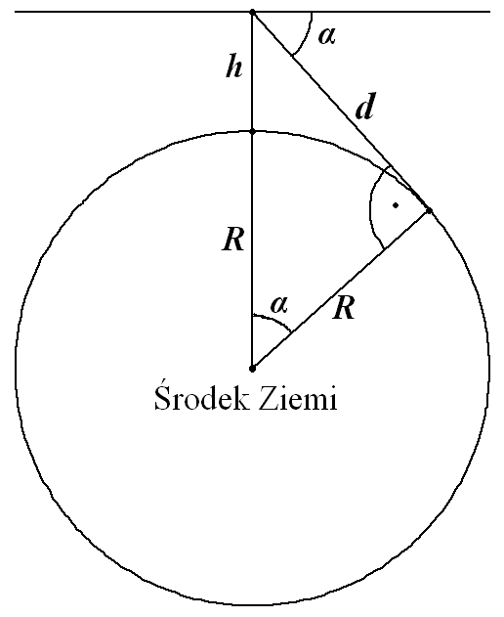The distance and dip of the horizon can be easily determined based on the figure on the left. If we assume that the Earth's surface is a sphere with radius R, the horizon will be a circle with radius r = R·sin α, where α is the horizon dip. This is also the radius of curvature of the horizon. The horizon dip is the angle between the plane perpendicular to the vertical direction at the observer's location and the direction of the horizon. We can calculate it from the relationship sin(π/2 – α) = cos α = R/(R + h), where π is a mathematical constant (3.14159...), which, when expressing an angle in radians, corresponds to a value of 180°. Thus:
Earth center
α = arccos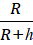 = arcsin{√[1 – (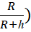²]}
We can calculate the distance to the horizon just as easily using Pythagoras' theorem d² = (R + h)² – R² = 2h·R + h², from which
d = √(2h·R + h²),
or from the already calculated angle α
d = R·tg α,
where R, h and d are expressed in the same units, and α – in radians.
These formulas are accurate and remain valid even for satellites, but since in practice h is much smaller than R, thus α is usually small, we can use the following approximations for this quantity:
α ≈ sin α = d/(R + h) = (2hR + h²)^{1/2}/(R + h) ≈ (2h/R)^{1/2} ≡ √(2h/R).
Assuming R = 6371000 m (the average radius of our planet) for the Earth and converting the units from radians to arc minutes (factor 180·60/π), we get
α ≈ (180·60/π) ·√(2/R)·√h = 1.926·√h,
where h is expressed in meters and α in minutes. This approximation can be found in the literature, but with a factor of 1.8 in front of the square root, which significantly compensates for atmospheric refraction (see below).
Table 1 shows the calculations of these two quantities for several heights h above the Earth's surface. It shows that the approximation of 1.926√h is very good up to an altitude of 100 km, where the error is 100·(609.1 – 605.2)/605.2 = 0.64%. Even at an altitude of 1000 km, the error is only about 6%.
Table 1. Horizon dip, α, and distance, d, as a function of the observer's height above the Earth, h (r is the radius of the horizon), calculated with approximate formula and exactly.
h | 1.926·√h | arccos[R/(R+h)] | d | r
[m] | [′] | [′] | [m] | [m]
10  100  1000  10000  25000  50000  100000  500000  1000000  10000000  100000000 | 6.1  19.3  60.9  192.6  304.5  430.7  609.1  1361.9  1926.0  6090.5  19260.0 | 6.1  19.3  60.9  192.5  304.1  429.3  605.2  1319.6  1811.6  4025.9  5194.0 | 11288  35696  112884  357099  564955  799749  1133225  2573130  3707020  15080450  106180035 | 11288  35695  112867  356539  562747  793522  1115713  2385884  3204100  5868765  6359562

Horizon Curvature
When we are positioned exactly at the center of a circle, we see each segment of the circle as its chord, i.e., as a straight line segment. However, when viewing such a segment of circle from any height, we see it as an arc above the chord. The bulge above the chord becomes more pronounced the higher we look from and the larger the angle of view. If we take photos of the horizon from a height h (see the figures below) and our camera or camcorder has a field of view (angle) γ, the ends of the part of the horizon visible in the resulting image (photo) will be as far from the device (camera) as any point on the entire horizon, i.e., by d, and the distance between them, i.e., the chord length, x, will be:
x = 2d·cos(π/2 – γ/2) = 2(2h·R + h²)^{1/2} sin(γ/2).
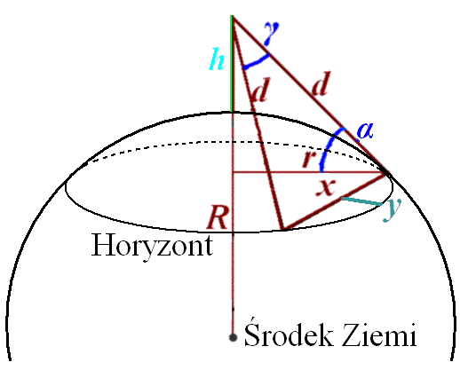

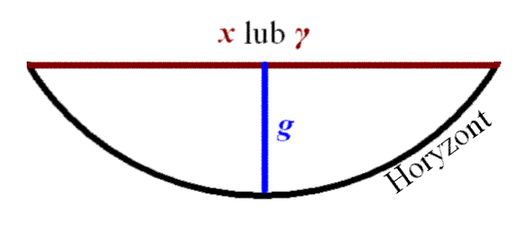
or

Horizon
Earth center
The center of the chord connecting the mentioned ends will be at a distance from the observer d·cos(γ/2). The distance, r', of this center from the vertical line and the depression of the direction towards this center from the camera relative to the horizon plane, α', will be respectively:
r' = d·[cos²(α) – sin²(γ/2)]^{1/2} and
α' = arccos[r'/(d·cos(γ/2)] = arcsin[sin(α)/cos(γ/2)].
The non-obvious right-hand expression for α' is easily obtained using the relationship arccos x = arcsin[√(1 – x²)].
On the horizon plane, the distance between the cord center and the top of horizon above it is
y = r – r' = R·sin α – r' = d·cos α – r'.
From the vantage point, the top of the horizon bulge will be visible above the chord at an angular distance g = α' – α. Thus we have an exact expression for this quantity:
g = arcsin[sin(α)/cos(γ/2)] – α,
but for small angles α (which in practice is true for angles γ less than 120°, even up to a height of h = 50,000 m), we can simplify it to
g ≈ α/cos(γ/2) – α = α [1/cos(γ/2) – 1]
to obtain a simple formula (giving the result in radians):
g ≈ √(2h/R)·[1/cos(γ/2) – 1].
Expressing h in meters and scaling the whole thing as before for α, we obtain a novel formula (giving the result g in minutes of arc):
g ≈ 1.926·√h·[1/cos(γ/2) – 1].
As a measure of the bulge of the horizon, we can use the percentage ratio of the angle g to the field of view or the angular distance between the edges of the horizon visible in the image, i.e., 100·g/γ.
The Effect of Refraction and Practical Formulas
Refraction (change of direction of light at the boundary of atmospheric layers with different refractive indices, which depend primarily on air temperature and pressure) allows one to see slightly beyond the geometric horizon from altitudes greater than zero – the further beyond the higher is the altitude. At altitudes reaching the stratosphere, a correction for refraction of approximately 0.5° can be expected. In the atmosphere, a light ray follows an upward convex curve. This means that a ray tangent to the spherical Earth at a geometric distance d from the observer will arrive slightly below the observer (located at altitude h), which is equivalent to a reduction in angle α. In calculations of the horizon distance and dip, this can be taken into account by increasing the Earth's radius, R. One model compensates for refraction by increasing the Earth's radius by a factor of 7/6, leading to the approximations:
α ≈ 1.926·√(6/7) ·√h = 1.78·√h
d ≈ √[2h·(7/6) ·R + h²] = √[(7/3)·h·R + h²] ≈ 3856·√h.
If we express h in meters in these formulas, we get α in arc minutes, and d in meters. Expressing d in nautical miles (1 NM = 1852 m; 3856/1852 = 2.08), we obtain the formula used in navigation: d = 2.08•√h (e.g., Navipedia). However, these approximations fail at high altitudes, say above 100 km. Refraction can be similarly accounted for in the formula for the bulge g:
g ≈ √[2h·(6/7)/R]·[1/cos(γ/2) – 1] = 1.78·√h·[1/cos(γ/2) – 1].
Calculations of the angle g = α' – α using exact formulas for several heights h (in meters) and selected fields of view γ (in degrees) are provided in Table 2. The absence of a percentage value in this table indicates that the entire horizon is within the field of view; in this case, r' = 0, and the chord becomes the diameter of the horizon, x = 2r.

Table 2. Observed horizon bulge, g (expressed in arc minutes and percentage of the angle at which the chord is visible, γ), above the chord as a function of the observer's height above the Earth, h, for selected fields of view, γ.
Calculations were performed using exact formulas, taking into account mean refraction. Missing numerical data indicate situations when for very high altitudes the observer field of view envelopes entire horizon.
Height | Field of View, γ
h | 30° |  | 60° |  | 90° |  | 120° |  | 150°
[m] | ['] | [%] | ['] | [%] | ['] | [%] | ['] | [%] | ['] | [%]
10 100 1000 10000 25000 50000 100000 500000 1000000 5000000 10000000 | 0.199  0.629  1.989  6.293  9.956  14.09  19.97  45.34  65.32  168.2  282.1 | 0.011  0.035  0.111  0.350  0.553  0.783  1.109  2.519  3.629  9.344  15.68 | 0.872  2.759  8.724  27.60  43.68  61.86  87.72  200.6  292.0  868.7  1514.2 | 0.024  0.077  0.242  0.767  1.213  1.718  2.437  5.573  8.111  24.13  — | 2.34  7.39  23.4  73.9  117.1  166.0  235.9  549.7  823.6  2202.9  1514.2 | 0.043  0.137  0.433  1.369  2.168  3.074  4.368  10.18  15.31  —  — | 5.64  17.8  56.4  178.7  283.5  403.1  576.4  1432.9  2560.0  2202.9  1514.2 | 0.078  0.248  0.783  2.482  3.937  5.598  8.006  19.90  35.56  —  — | 16.1  51.1  161.6  514. 8  824.1  1191.2  1771.0  4172.9  3708.8  2202.9  1514.2 | 0.179  0.567  1.796  5.720  9.156  13.24  19.68  —  —  —  —
These calculations show that in practice, the horizon's curvature above the chord for fields of view up to 60° and an observation point altitude of up to 10 km is less than 1% of that 60° (i.e., 0.6°), making it difficult to see. Due to this small degree of horizon curvature, coupled with frequent image distortions resulting from imperfect camera optics (the "fisheye" effect), it is important that the horizon line (or rather, the chord) runs as precisely as possible through the center of the resulting image.
Flat Earth advocates claim that the lack of horizon curvature can be verified by placing a straight board or beam horizontally at eye level on the seashore. Suppose such a board is 3 meters long and placed 10 meters above sea level, and we look at it so that we can see its ends on the horizon, encompassing a horizon angle of view of 60°. This means that our eyes are at a distance of 3 m from the ends of the board, and 3·cos(60°/2) = 2.60 m from its center. The angle of curvature of the horizon read from Table 2 is in this case g = 0.872' (approx. 0.024% of 60°), or calculated using the given approximate formula 1.78·√10·[1/cos(30°) – 1] = 0.870'. This further means that at a distance of the board, the horizon will protrude above it by 2.60·tg g = 0.0007 m, i.e. less than 1 mm. Even if the board is perfectly level, such a small curvature is unlikely to be noticeable. A similar calculation for the field of view γ = 120° (the distance of the eyes from the center of the board will then be 0.87 m) gives only about twice as high bulge above the board: 0.87·tg(5.64') = 0.0014 m, i.e. 1.4 mm.
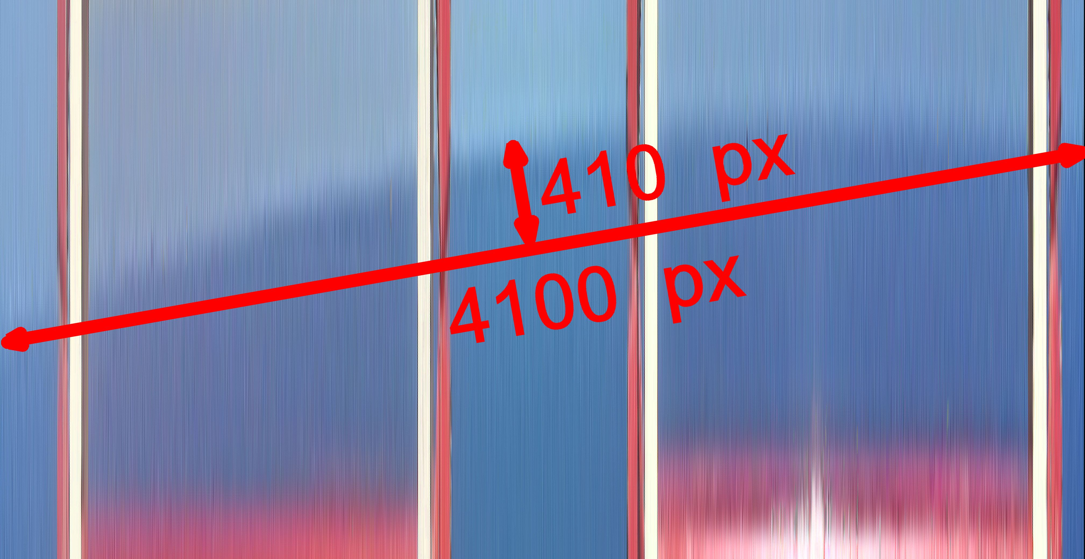
The page Left to right curve of the horizon features a photograph of the horizon, viewed through the slits of a special device, taken from a height of h = 184 m with a field of view of γ = 63.7° (EXIF data). The expected bulge is therefore 1.78·√184·[1/cos(63.7/2) – 1] = 4.3′, which is (4.3/60)/63.7·100 = 0.11% of the field of view. In a fragment of the aforementioned photograph (see the accompanying image) vertically enlarged by a factor of 100, a bulge of approximately 410 px (pixels) can be seen (with an error of approximately 10%) over a chord length of approximately 4100 px, or 0.1% of the field of view. This is consistent with the expected value of 0.11%.
And one more note for flat earthers. Sometimes objects far beyond the calculated horizon are observed but it doesn't mean that the Earth isn't a sphere, as the formulas given here take into account the average astronomical refraction, and the actual refraction depends on temperature and pressure. Furthermore, one has to remember that there are phenomena such as terrestrial refraction and mirages.
K.M. Borkowski
Toruń (Poland), 17 May 2024

